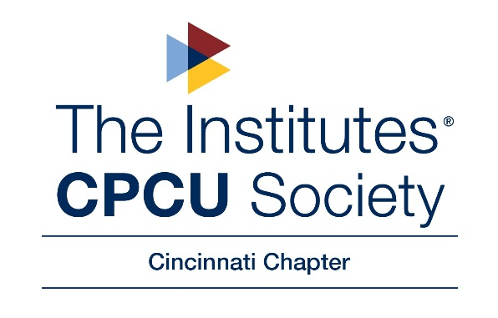
Cincinnati CPCU Society Chapter
Gamma Iota Sigma Scholarship
2022

This year the Cincinnati CPCU Society Chapter will award a $500 scholarship(s) to paid and participating members of University of Cincinnati’s Gamma Iota Sigma as part of our mission to provide educational financial assistance to a new generation of students who are committed to learning how insurance serves our society and are pursuing an interest in insurance careers. These students should excel in academics, community service activities and school-related activities. In addition, students must submit an essay.

This scholarship may be for you if...

- You are a paid and active member in Gamma Iota Sigma

- You are a current member of Cincinnati CPCU Society Chapter.

Join the CPCU for FREE as a GIS member! Click "Join Now" under the student member section to start your membership registration for FREE or call 800-932-2728 to sign up.

You will find amazing educational opportunities, professional development, and a community of colleagues and experts around the world that want to help you be your best. You will receive newsletters and updates to keep you informed about the national CPCU society and our local Cincinnati Chapter. Check out more information about the society at the CPCU website https://www.cpcusociety.org/

- You have at least a 3.0 GPA and will be attending University of Cincinnati this Summer or Fall.

Your application must be received by noon on April 15, 2022.

The scholarship may be used for tuition, room and board, books, CPCU materials and/or CPCU exams.

The winner will only be able to receive 1 scholarship if eligible for both “Cincinnati CPCU Society Scholarship” and “Cincinnati CPCU Society Chapter – Gamma Iota Sigma Scholarship.”
Cincinnati CPCU Society Chapter
Gamma Iota Sigma Scholarship
2022 Application
First Name Middle Initial Last Name

Date of Birth Email Address Phone Number
Address City State ZIP

A submission is complete when it includes all of the following items:

1. The completed application.

2. Most recent college grade report.

3. Community service activities and hours spent on each activity.

4. School activities and hours spent on each activity including your specific participation in GIS activities.

5. The qualification essay on a separate page(s).
Essay Rules for Cincinnati CPCU Society Chapter - Gamma Iota Sigma Scholarship
- All essays must be typed and double-spaced.
- Essays must be 250-500 words in length.
- Submissions that include handwritten essays will be rejected.
- 2022 Essay Prompt
How can the insurance industry be more effective in reaching college students regarding a career in the insurance industry and the many opportunities that exist?

Only electronic submissions will be accepted.

I hereby certify that all the information contained within, and attached to this application is, to my knowledge, accurate. I understand that, if awarded a scholarship under this program, I will enroll in classes at an accredited post-secondary educational institution in either the Summer or Fall of 2022, or forfeit the monies in the award.
Applicant Signature Date

Applications must be received electronically no later than noon, April 15, 2022.
Winners will be notified by email.

Please send your essay and supporting documents to: cincinnatichapter@cincinnaticpcu.org

